**Types of Keys:**

**In PRPC we have 2 types of Keys:**

**1. Class Key- (Is a Class Group, Belongs to Class Group & Data Types)**

**2. Primary Key (Also Called as pzInsKey) - ( Obj-Open-by-Handle)**

**Class Key:**

**we will define class key while Creating Data Tables/Data Type. We can add One or more class keys to add a dedicated table.**

**We will have class key assigned for our Work Class Group. i.e pyID**

**Open Class Definition for your Work Class group:**

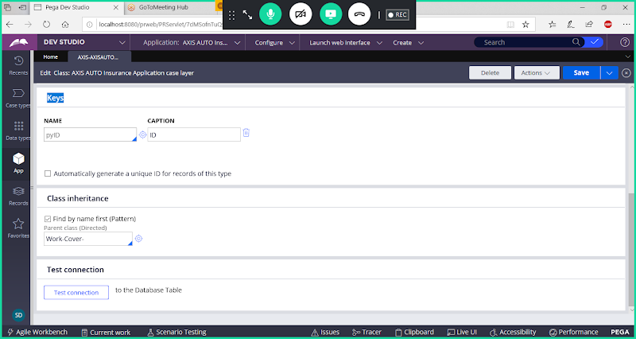

**-----------**

**How to Know Primary Key?**

**Primary Key in PEGA PRPC is pzInsKey**

**Open Server: For Every Table ( pc, pr & pr4 Tables) the primary key will be assigned by default.**

**For Any Table in PEGA Primary Key is pzInsKey**

**Open your Work Table: pc_OrgName_DivName_work**

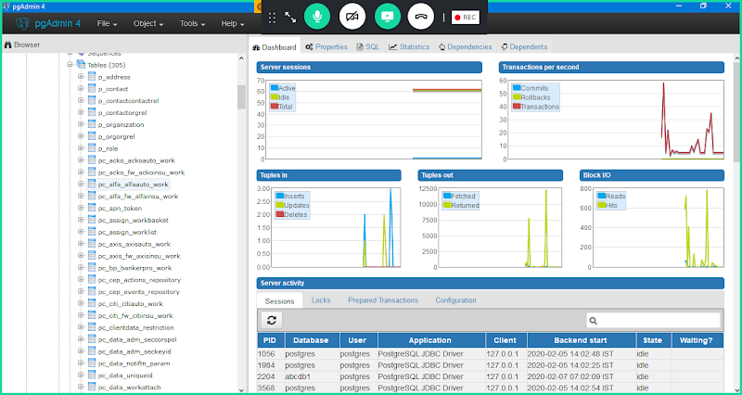

**Right Click on Work Table-> Properties**

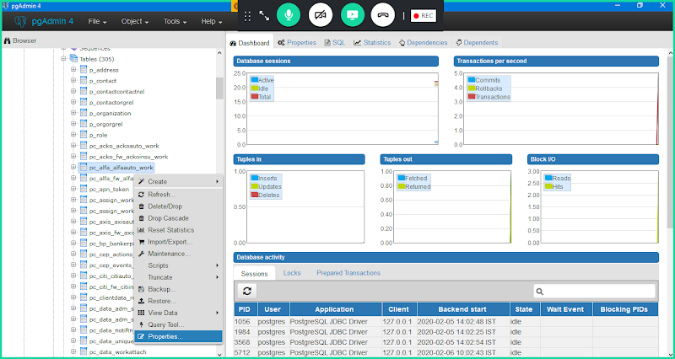

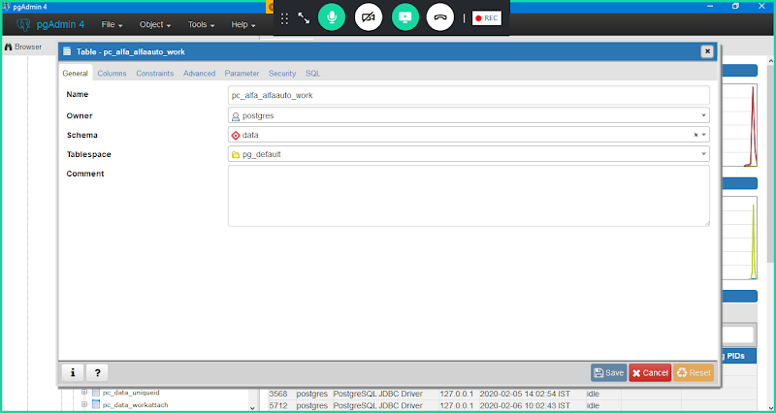

**Click on Constraints**

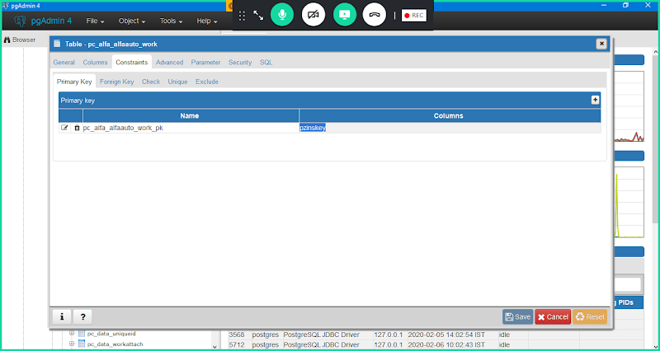

**Here in above screen Primary Key is pzInsKey**

**pzInskey is Primary Key for all the Tables. ( Pc, Pr, Pr4 Tables)**

**What is the format of pzInsKey in Work Table?**

**Ans: Right Click on Work Table-> View Data-> View All Rows**

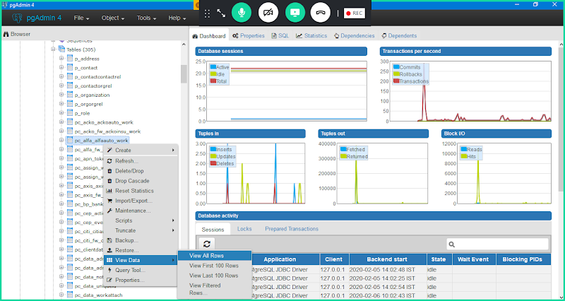

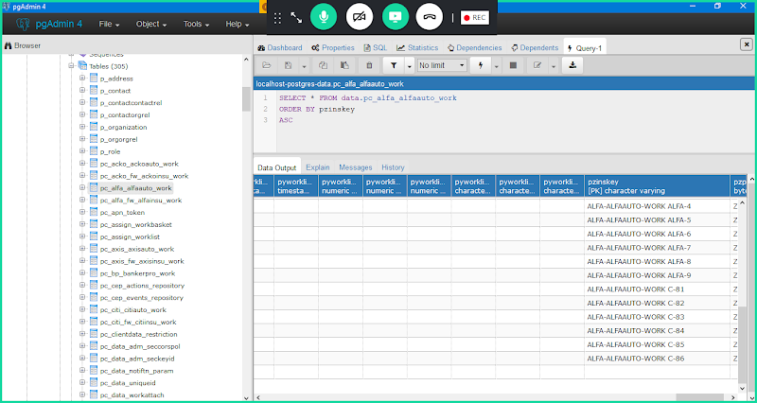

**Class Group Name  Work ObjectID**

**"ALFA-ALFAAUTO-WORK  C-1"**

**How to identify Primary Key for any Rule or Individual instance & What is the Format of pzInsKey at Rule Level?**

**Ex: Open Age Property Rule**

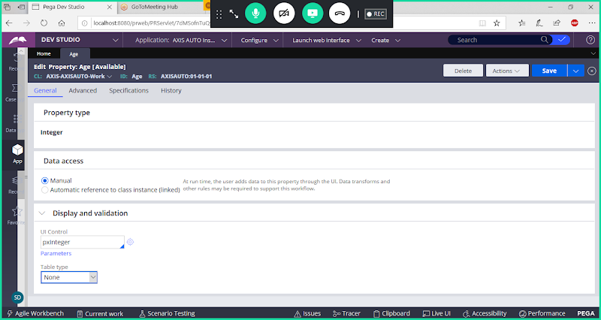

**Go to Actions -> View XML**

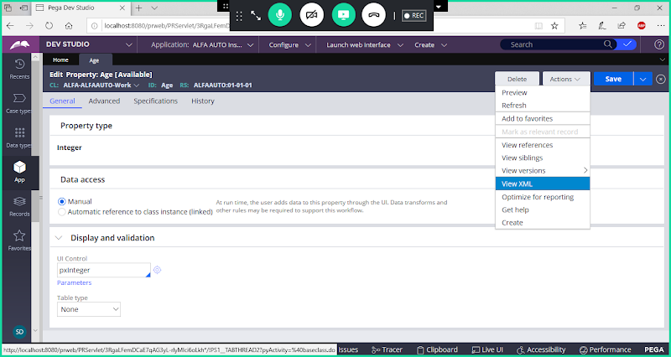

**Search for pzInsKey:**

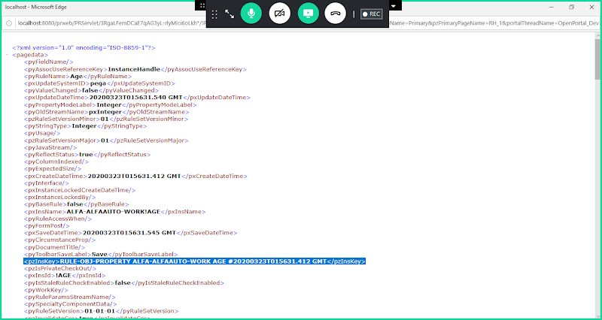

**<pzInsKey>RULE-OBJ-PROPERTY ALFA-ALFAAUTO-WORK AGE #20200128T022739.364 GMT</pzInsKey>**

**RULE-OBJ-PROPERTY    ALFA-ALFAAUTO-WORK          AGE                   #20190304T011117.704 GMT**

**Rule Instance                   Rule Class                       Rule Name                   Time Stamp**

**pzInsKey is Primary Key for any table in PEGA**

**pzInsKey is Primary Key for any Rule in PEGA**

**===**

**What is the purpose of Primary Key:**

**To uniquely identify any instance in the rule base( pc/pr/pr4) and bring back & display in PRPC Platform.**

**=========**

**Working with Obj-Open-by-Handle:**

**Purpose of  Obj-Open-by-Handle: To fetch single Record based on  primary key/ pzInsKey**

**Req: Create a Generic Activity to Update Any WO Status from Old Status to New Status:( Use Parameters)**

**Update status from Pending-CustInfo to Pending-NewCustInfo**

**Old Status:  Pending-CustInfo**

**New Status:  Pending-NewCustInfo**

**Execute Insurance Flow & create 2 work Id's with Old Status( Pending-CustInfo)**

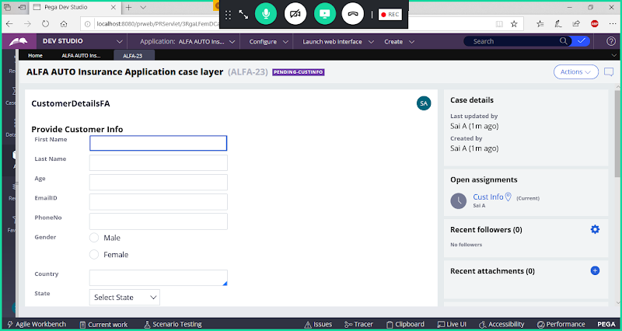

**Create 2 WO's with Pending-CustInfo Status:  ALFA-23, ALFA-24**

**Create Activity in Organization Class :**

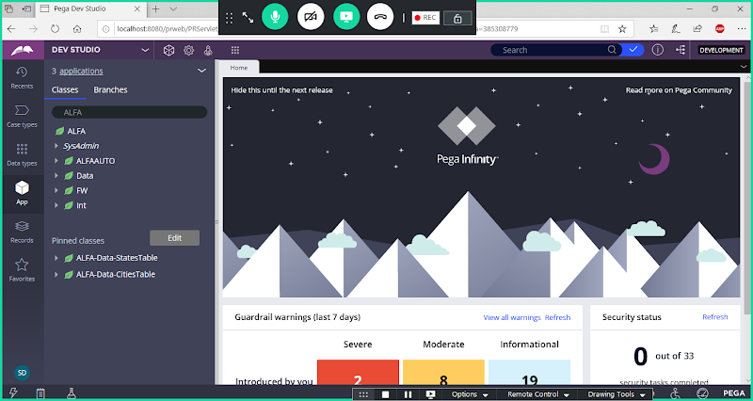

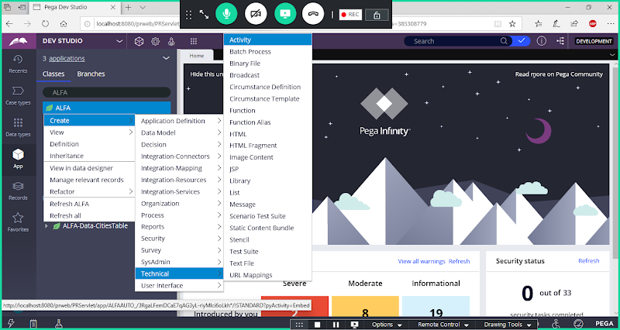

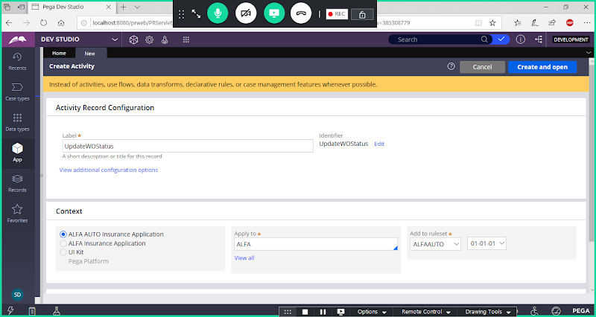

**open**

**Go to Pages & Classes**

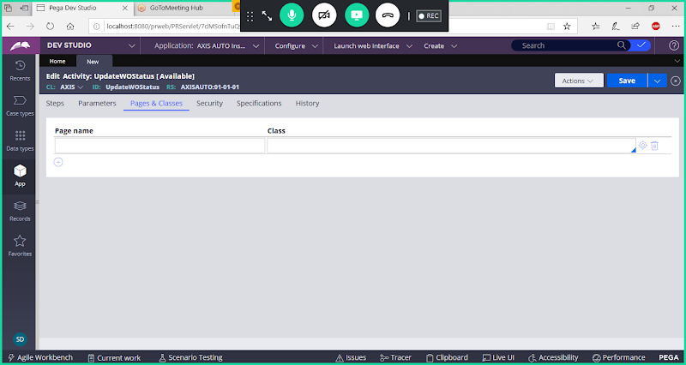

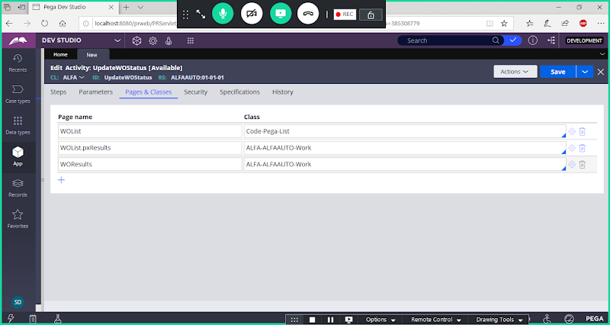

**Go to Parameters tab:**

**Add 2 Parameters & Set Required Option as Yes**

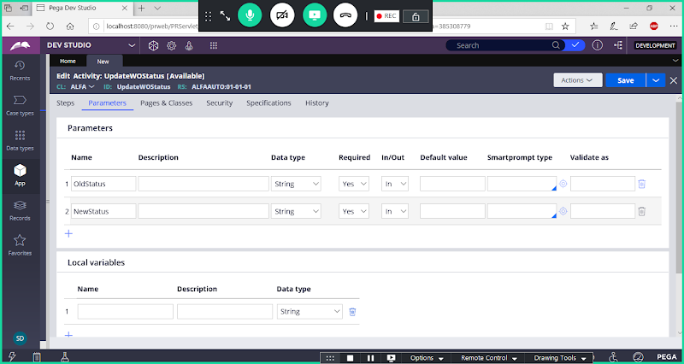

**Go to Steps tab:**

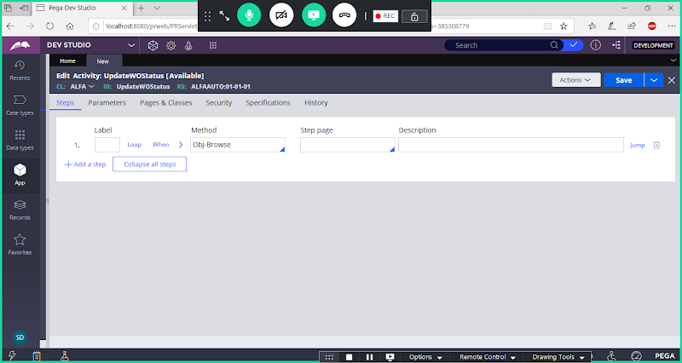

**Expand Method & Fill Parameters:**

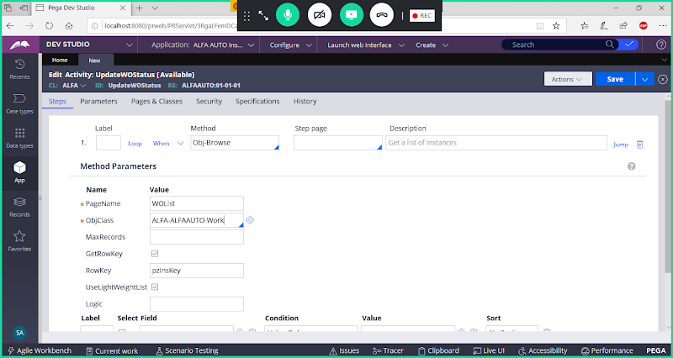

**Disable GetRowKey**

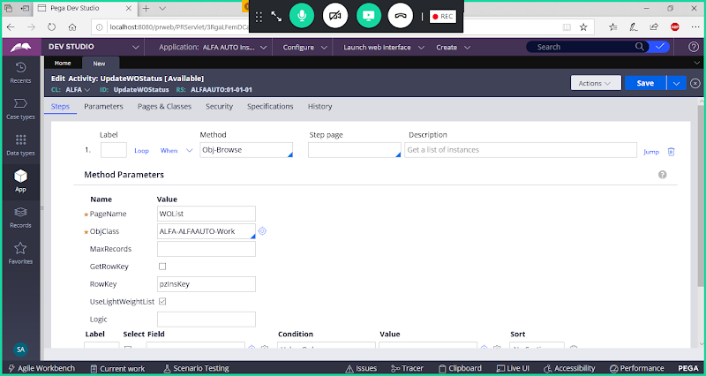

**Using Obj-Browse we will browse the data and keep on clipboard. Further we are going to use this data.**

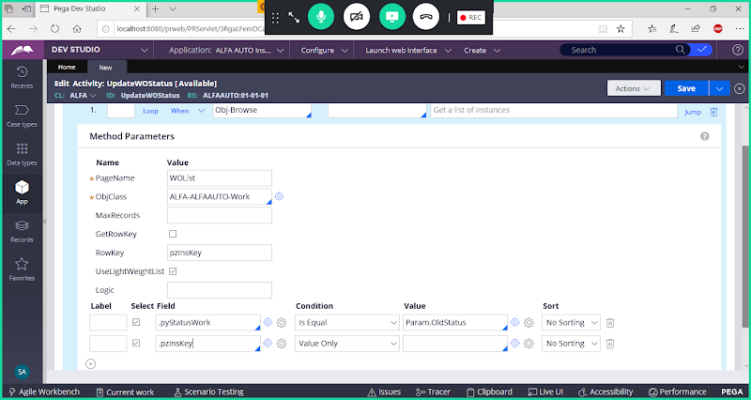

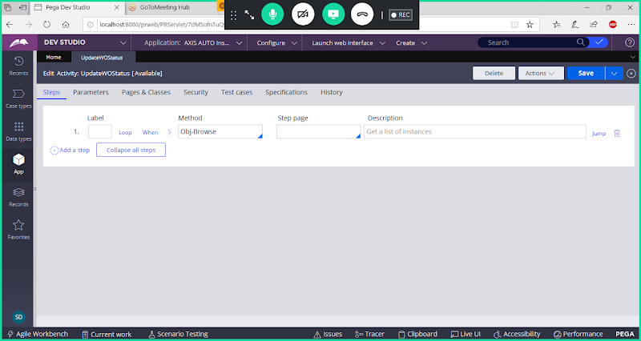

**In New Step Add Step Page**

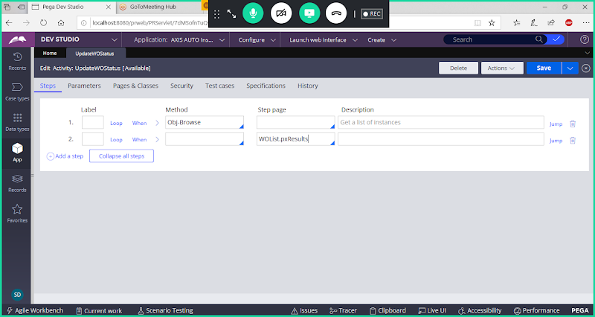

**Now Add Loop Condition**

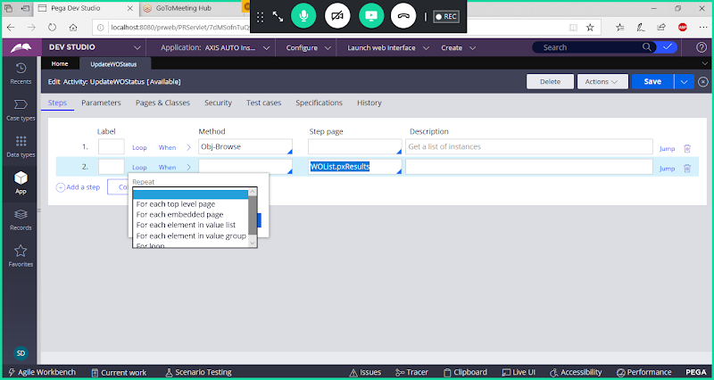

**Select Loop Condition: For each embedded page**

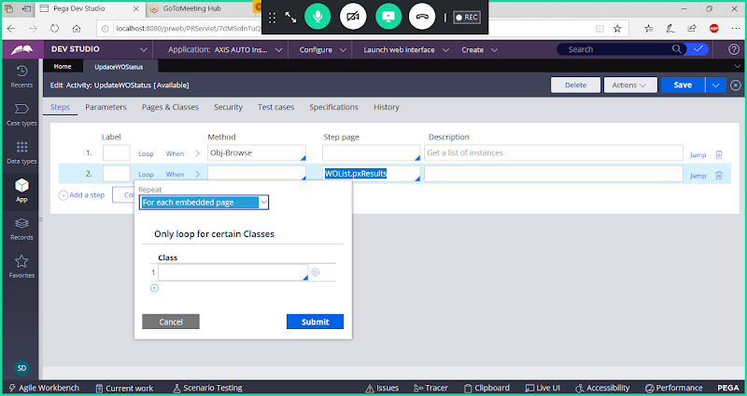

**Now click on submit**

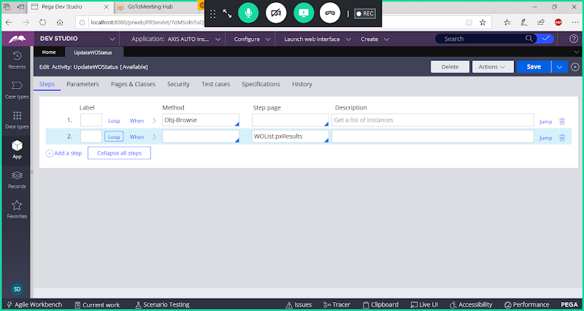

**Right Click on Step 2 & Click on Add Child**

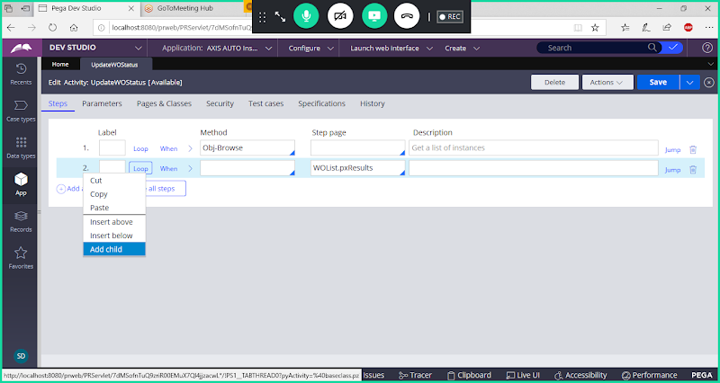

**In 2.1 - > Add Page-New Method**

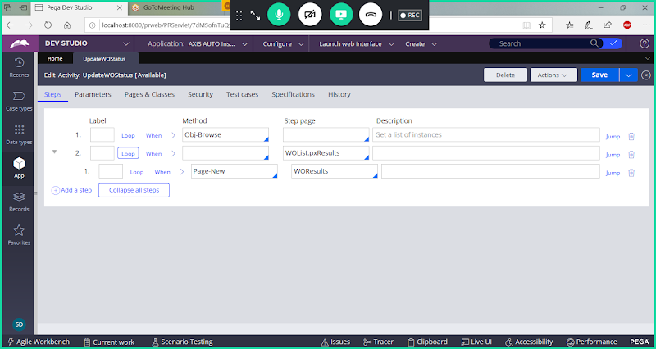

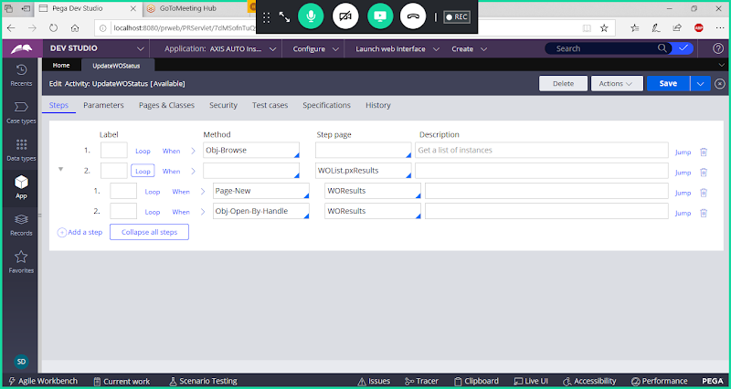

**Fill Parameters for Obj-Open-by-Handle**

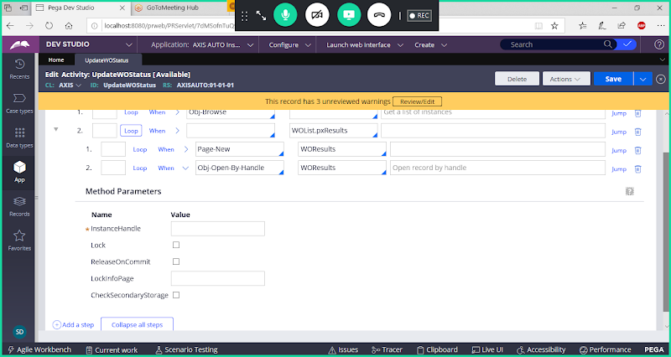

**Provide Instance handle:     WOList.pxResults(<Current>).pzInsKey**

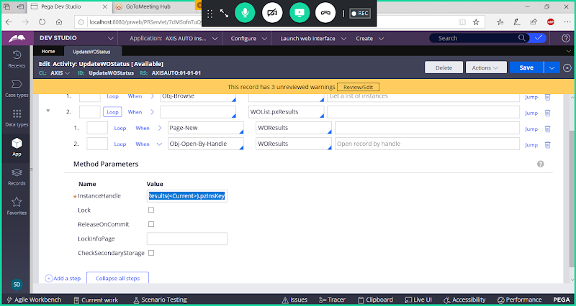

**Enable Lock & Release on Commit options**

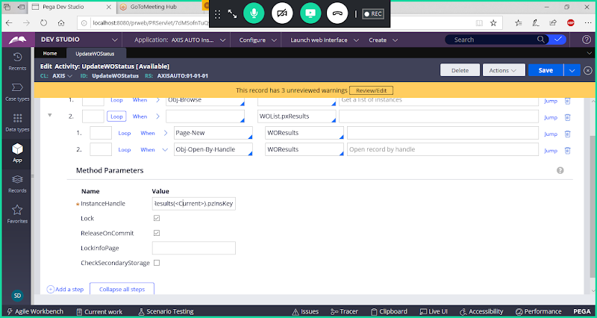

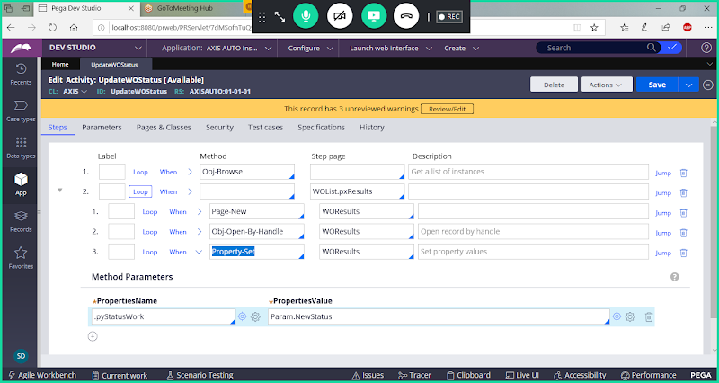

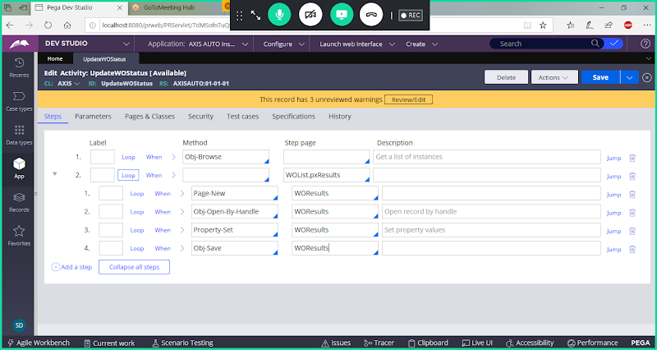

**Click on Collapse all steps**

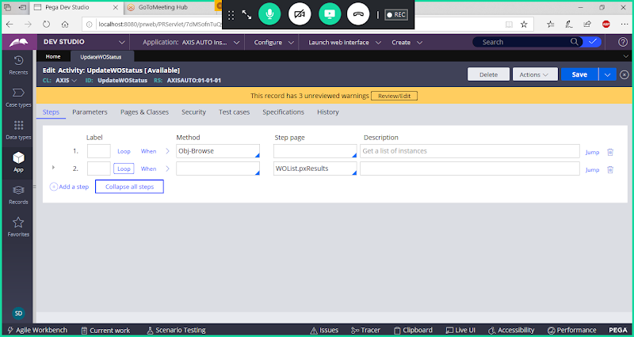

**Add step 3 outside the loop:**

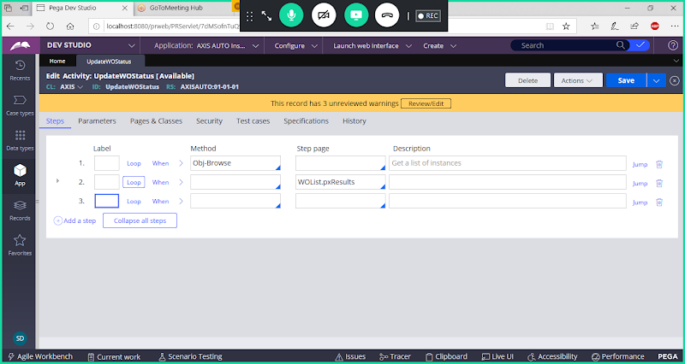

**Use Call to call the API ( commitwitherrorhandling)**

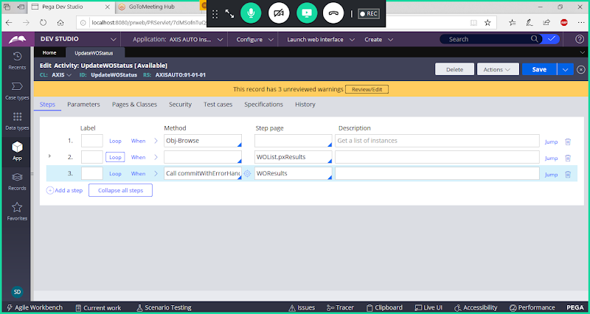

**Call commitWithErrorHandling**

**If we use commit inside the loop, here the thread is already committed by using Obj-save. In that case if any records fails it will stop there. So we have to use commit API outside the Loop.**

**Save activity & Run Activity**

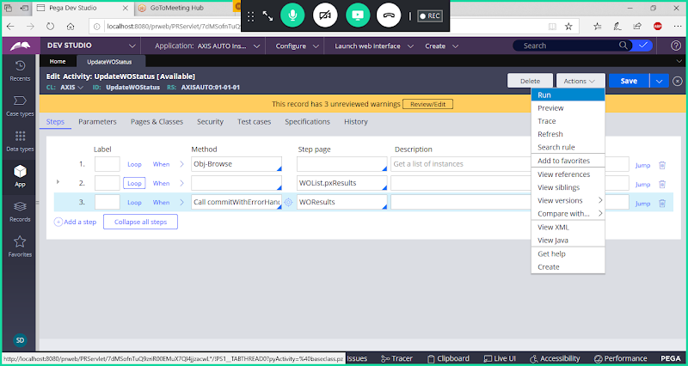

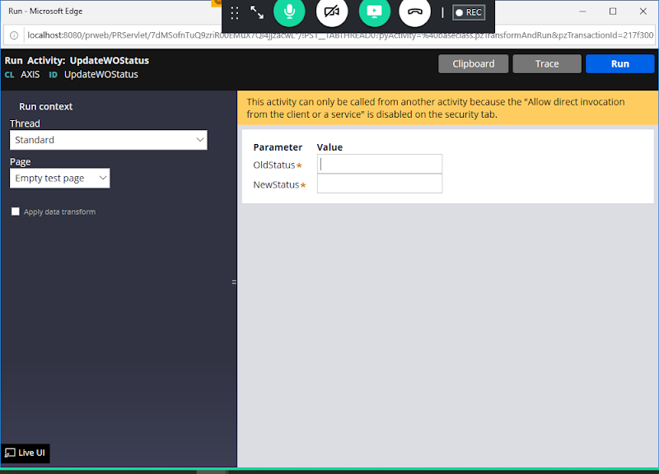

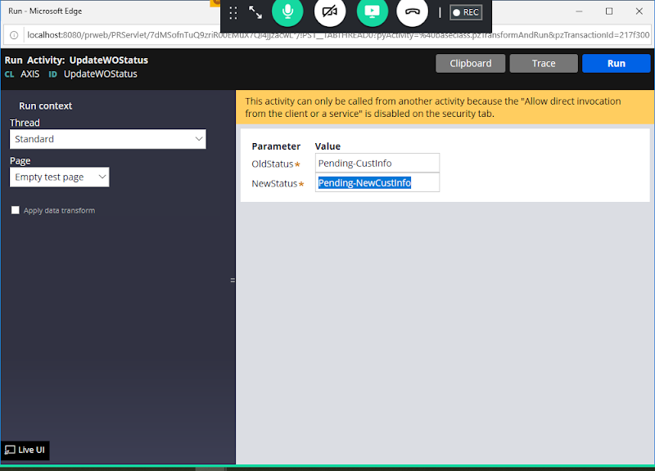

**Click on Run**

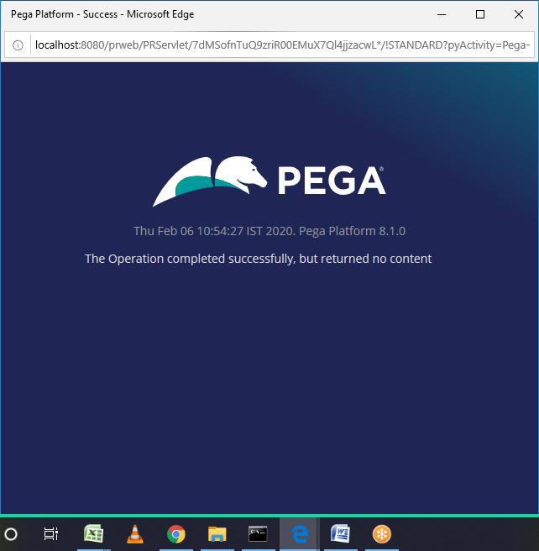

**Verify WorkId's  status whether updated to New Status or not**

**Click on Work Class Group**

